Name______________________
Student Number_______________________

ORGANIC CHEMISTRY II

FINAL EXAM

AUGUST 10th, 2010
TIME ALLOWED: 180 min

NO MODELS OR CALCULATORS ALLOWED.
NO PAGERS OR MOBILE PHONES ALLOWED.

WRITE YOUR NAME AND STUDENT NUMBER ON EVERY PAGE OF THE
EXAM.

ONLY THE ANSWERS PROVIDED ON THE ANSWER SHEET WILL BE
MARKED.

ROUGH WORK SHOULD BE DONE ON THE QUESTION PAGES.

NO OTHER PAPER MAY BE USED IN THIS EXAM.

Read through the test before you begin.

Section I.
MCQ_______ (20)
2.___________(10)
Section II.

1.___________(31)
2.___________(8)
3.___________(5)
4.___________(8)
5.___________(28)
6.___________(40)

Total Marks___________/150

MULTIPLE CHOICE. Choose the one alternative that best completes the statement or answers the question. (20 marks, 2 marks each)

1. Which of the following m/z values is the base peak for benzyl alcohol?

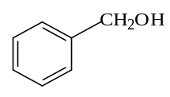
A) 17 B) 54 C) 91 D) 105 E) 78

2. Five compounds are shown for the IR spectra seen below. Indicate which of the five compounds is responsible for the spectrum.
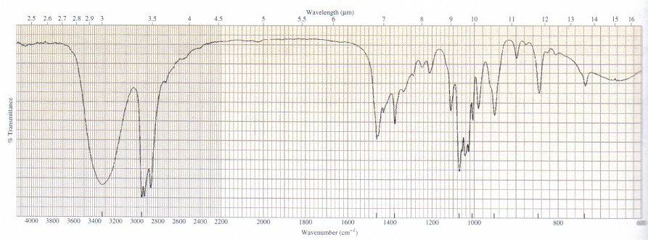

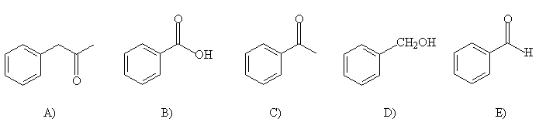
3. Which of the following species has a characteristic broad absorption at 3200 – 3500 cm⁻¹ in its IR spectrum?

- PhCH₂CN
- PHCH₂CH₂OH
- PhCH₂N(CH₃)2
- PhCH₂CO₂CH₃
- PhCH₂OCH₂Ph

4. How many signals would you expect to see in the ¹H NMR spectrum of the following compound?
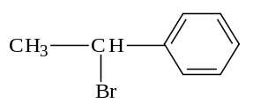
A) 3 B) 4 C) 2 D) 1 E) 5

5. Which set of protons in the following compound is the least shielded?
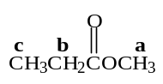

A) a and b B) a C) c D) c and b E) b

6. How many signals are in the ¹³C NMR spectrum of the following compound?

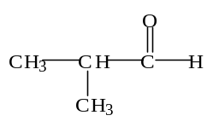
A) 4 B) 3 C) 2 D) 1 E) 5

7. Which of the following is aromatic?

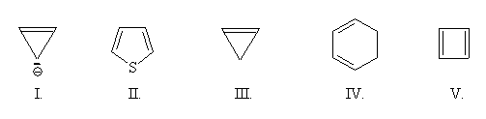
A) I B) II C) III D) IV E) V

8. Which of the following is a strong acid?
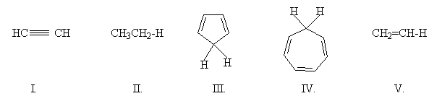

A) I B) II C) III D) IV E) V

9. What is the major product of the following reaction?

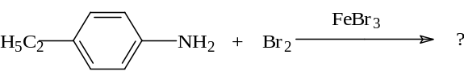
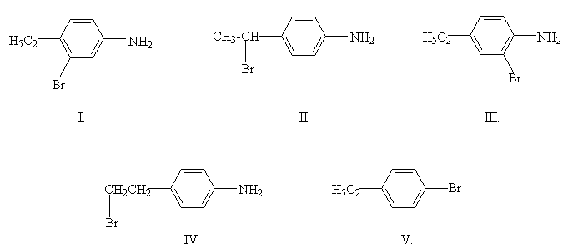

A) I B) II C) III D) IV E) V

10. Which of the following statements best explains the information we can gain from mass spectrometry?

- It allows us to determine the presence and nature of a carbocation in the compound.
- It allows us to determine the number of protons in the compound.
- It allows us to determine the molecular weight and the mass of some fragments of a compound.
- It allows us to determine the presence and nature of a free radical in the compound.
- It allows us to determine the kinds of functional groups in a compound.

Name____________________________________
Student Number__________________________

Answer Sheet
Section I. Multiple Choice.

1 | A | B | C | D | E
2 | A | B | C | D | E
3 | A | B | C | D | E
4 | A | B | C | D | E
5 | A | B | C | D | E
6 | A | B | C | D | E
7 | A | B | C | D | E
8 | A | B | C | D | E
9 | A | B | C | D | E
10 | A | B | C | D | E

SHORT ANSWER QUESTION.

2. A compound with molecular formula C₅H₁₀O₂ gives the following IR spectrum. (10 marks)

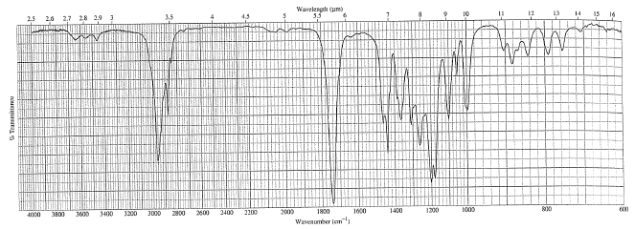

When it undergoes acid-catalyzed hydrolysis, the compound with the following ¹H NMR spectrum is formed. Identify both compounds and explain your answer.

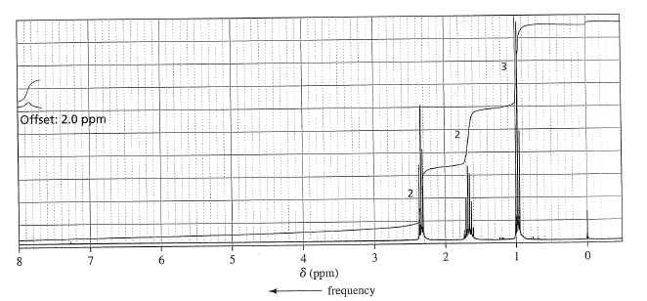

Name____________________________________
Student Number__________________________

Section II.
Short Answer Questions
Please Provide the Answers on the Answer Sheet.
1. Provide the major organic products of the following reactions. Show only major products and stereochemistry if necessary. (25 marks)

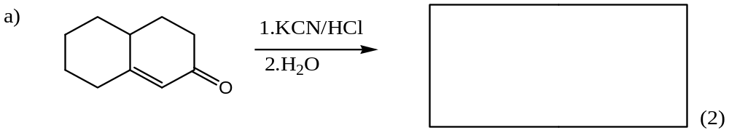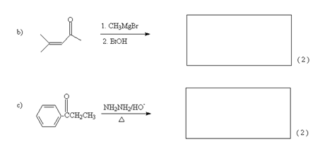
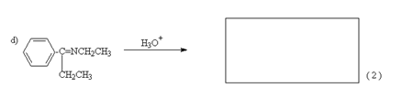

Name________________________________
Student Number_______________________

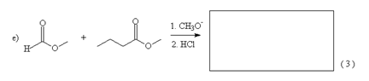

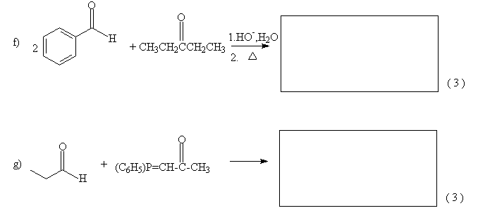
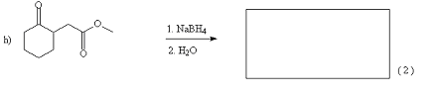
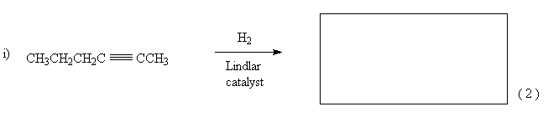

Name________________________________
Student Number_______________________

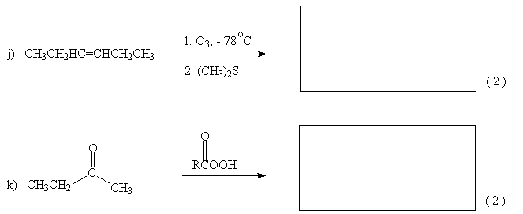

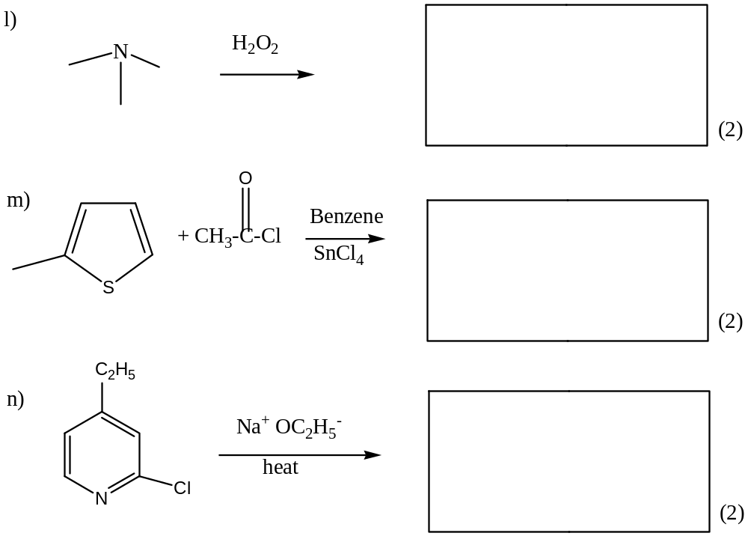

Name________________________________
Student Number_______________________

2. A Hofmann degradation of a primary amine forms an alkene that gives butanal and 2-methylpropanal upon ozonolysis and work-up under reducing conditions. Identify the amine and show all intermediate compounds. ( 8 marks)

3. Indicate whether each of the following is true or false. (5 marks, 1 mark each)

- Pyridine is more reactive toward nucleophilic aromatic
substitution than is pyrrole T F
- Pyrrole is more reactive toward electrophilic aromatic
substitution than is furan T F
- Pyrrole is more reactive toward electrophilic aromatic substitution
than is benzene T F
- Pyridine is more reactive toward electrophilic aromatic substitution
than is benzene T F

- Pyridine is acidophobic and pyrrole is acidophilic T F

Name________________________________
Student Number_______________________

4. Give product(s) of each of the following reactions: (8 marks)

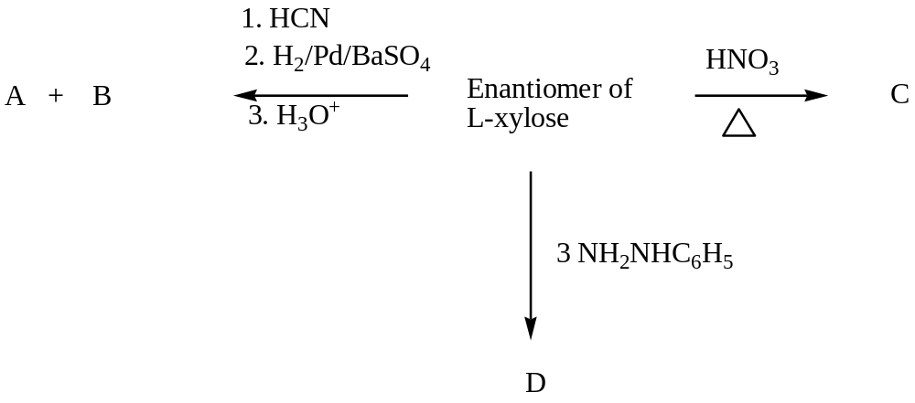

Name________________________________
Student Number_______________________

5. Show how each of the following compounds could be synthesized. You may use any inorganic or organic reagents. Multiple steps may be required. (28 marks)

a)
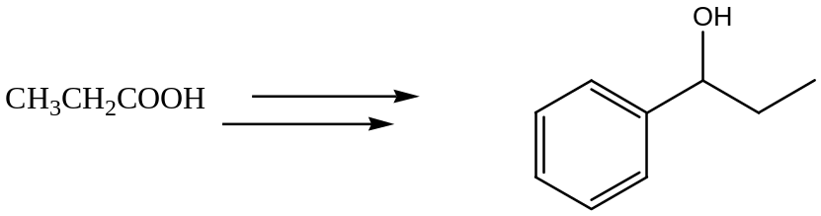

(6 marks)

b)
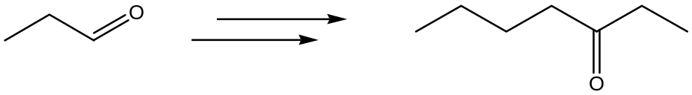

(6 marks)
Name________________________________
Student Number_______________________

c)
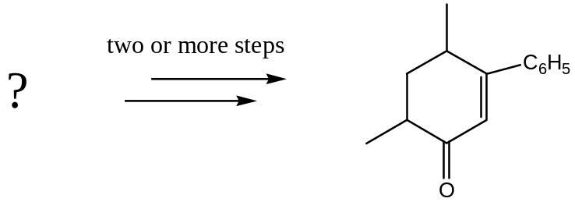

(8 marks)

d)
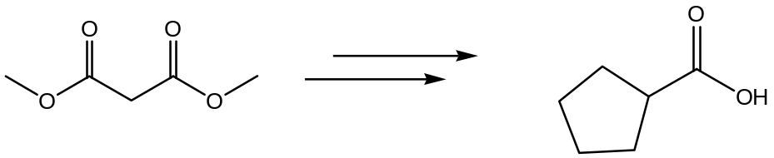

(8 marks)
Name________________________________
Student Number_______________________

6. Propose a mechanism for each of the following reactions. (40 marks, 10 each)

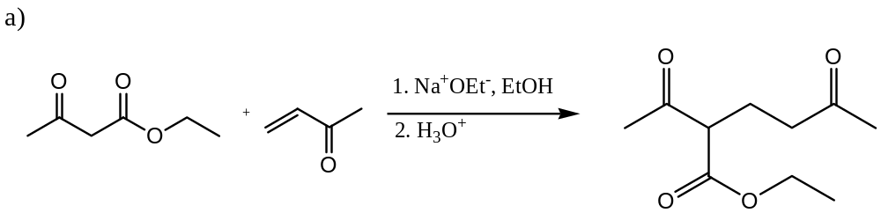

Name________________________________
Student Number_______________________

b)
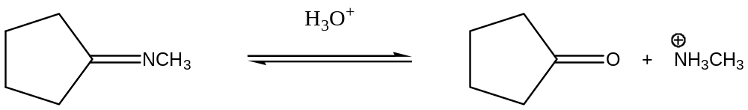

Name________________________________
Student Number_______________________

c)
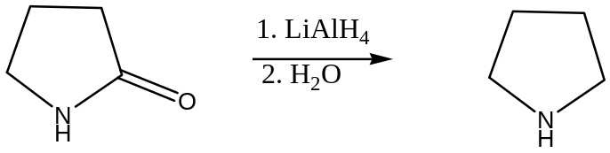

Name________________________________
Student Number_______________________

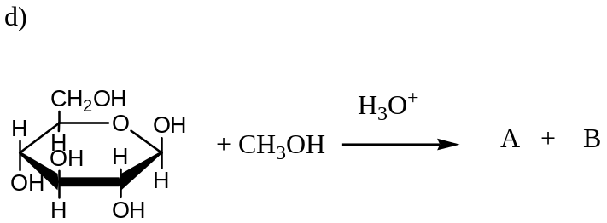

ROUGH WORK (WILL NOT BE MARKED)

